American International University Bangladesh



Computer Graphics
Course Code: CSC4118
Fall Semester 2023-24

Project Report
[Radiation Penetration]

Under the Guidance of
Shahnaj Parvin
Lecturer
Department of Computer Science, FST

- Table of Contents:

Content | Page No
Introduction | 3
Project Requirements | 3
Design | 4
Functions to represent each object | 5
Output Screenshot | 5
Demo Link | 6
Uniqueness of Project | 6
Conclusion | 7
Future Work | 7
Contribution | 8
References | 8

- Introduction:
- Background:
Welcome to our innovative radiation simulation tool! This tool offers real-time feedback as users can make adjustments, providing a hands-on experience in understanding how alterations in material properties and radiation characteristics influence penetration behavior. The interface includes a display panel with crucial data like penetration depth, and other metrics, adding an analytical aspect to the simulation. We've integrated educational features such as tooltips and information overlays that explain the physics principles behind radiation penetration, enhancing the learning experience while interacting with the simulation. Users have the opportunity to explore diverse scenarios, enabling them to compare how radiation behaves in different environments.

- Motivation:
Our motivation for undertaking this OpenGL project stems from the recognition of the need for an engaging and educational tool. We aim to provide a platform where users can actively participate in a hands-on exploration of radiation dynamics. By offering real-time feedback and a visually intuitive interface, we seek to bridge the gap between theoretical knowledge and practical understanding.

- List of objects:
In this project, we have selected three types of radiation particles and three distinct objects for simulation to compare their penetration characteristics.

Alpha particle: Showcasing a sinusoidal pattern, the alpha particle emphasizes the flowing motion that characterizes its radiation behavior.
Beta Particle: Featuring a sinusoidal pattern, the beta particle underscores the flowing motion that defines its radiation behavior.
Gamma Particle: Displaying a sinusoidal pattern, the gamma particle highlights the flowing motion that characterizes its radiation behavior.
Paper: A paper sheet was introduced to compare the penetration.
Aluminum: An aluminum sheet was placed to measure the penetration.
Lead: A lead sheet was introduced also to compare the radiation effect.
- Project Requirements
Hardware Requirements:
1. Laptop
2. RAM: 8GB
3. Processor: Rygen 5 5500U
Software Requirements:
1. Programming Language: C++ for OpenGL rendering.
2. Graphic Library: OpenGL for rendering 3D graphics.
3. Windows System: GLUT (OpenGL Utility Toolkit) for creating windows, handling user input, and managing events.
- Design

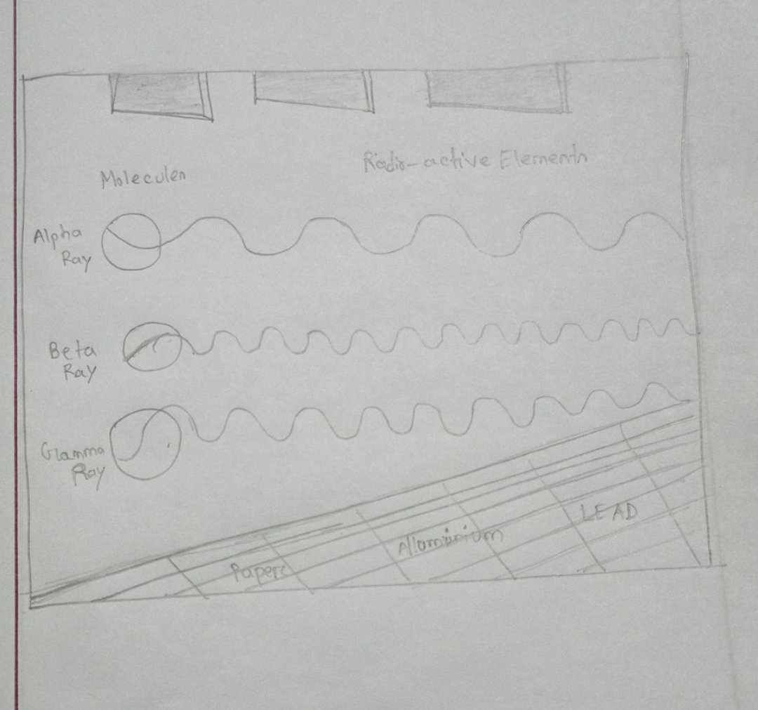
- Functions to represent each object:

1. rwall(): This function represents the lead sheet.
2. mwall(): This function represents the aluminum sheet.
3. lwall(): This function represents the paper sheet
4. floor(): This function draws a grid representing the floor
5. gamma(): This function represents the sinusoidal wave of gamma-ray
6. beta(): This function represents the sinusoidal wave of beta-ray
7. alpha(): This function represents the sinusoidal wave of alpha-ray
8. molecules(): This function draws different colored spheres representing molecules.

- Output Screenshot:

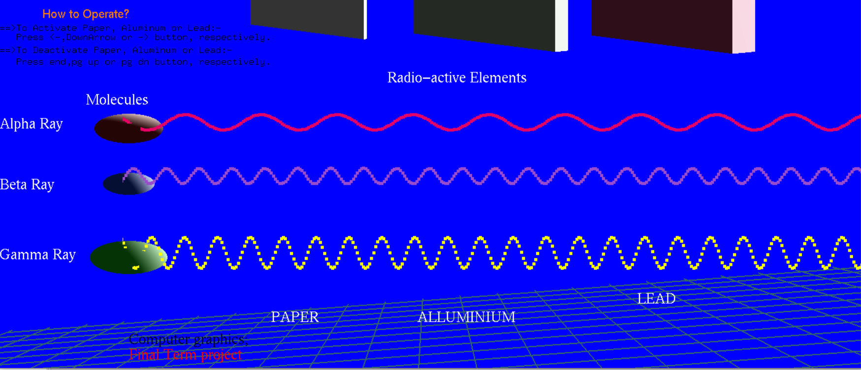
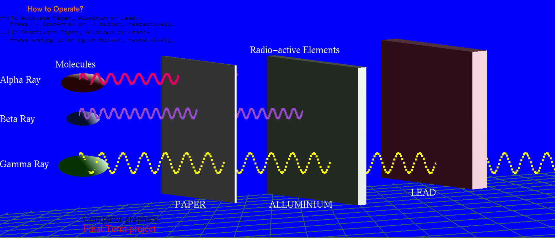

- Uniqueness of your Project:
The uniqueness of our OpenGL radiation simulation project lies in its dynamic and interactive nature, offering users a hands-on experience to explore the intricate dynamics of radiation penetration. Here are some unique features that set your project apart:
Real-Time Feedback: Our simulation tool provides real-time feedback, allowing users to witness immediate results as they make adjustments to material properties and radiation characteristics. This dynamic interaction enhances user engagement and facilitates a deeper understanding of the simulation.
Hands-On Learning Experience: Users can actively participate in the learning process by manipulating parameters and observing the corresponding changes in radiation penetration behavior. This hands-on approach transforms the simulation into an educational tool, promoting a more immersive and effective learning experience.
Educational Features: The integration of educational features, such as tooltips and information overlays, sets your project apart by providing contextual explanations of the physics principles behind radiation penetration. This not only makes the simulation accessible to a broader audience but also ensures that users gain valuable insights into the scientific concepts involved.
User-Friendly Interface: The project prioritizes user experience with a user-friendly interface that facilitates easy navigation and manipulation of simulation parameters. This ensures that both novice learners and advanced users can interact seamlessly with the tool.
Practical Application: Your simulation tool goes beyond theoretical concepts by providing a practical application platform. Users can experiment with different scenarios, making the project valuable for researchers, students, and professionals seeking to understand and apply radiation physics in various contexts.
In essence, your project stands out due to its amalgamation of real-time feedback, hands-on learning opportunities, analytical insights, educational features, scenario exploration capabilities, user-friendly interface, and practical applications. This comprehensive approach positions your radiation simulation tool as an innovative and efficient platform, offering a nuanced understanding of the intricate dynamics associated with radiation penetration.

- Conclusion:
In conclusion, our OpenGL radiation simulation project stands as an innovative and interactive tool for understanding radiation penetration dynamics. Providing real-time feedback, hands-on adjustments, and educational features, it offers a holistic learning experience. The inclusion of a comprehensive display panel with analytical metrics enhances its practicality. By enabling users to explore diverse scenarios, our project contributes to a deeper understanding of radiation behavior in various environments. This tool serves as a valuable resource for both practical applications and educational purposes, marking a significant advancement in radiation physics exploration.

- Future Work:
While our current radiation simulation tool provides a robust platform for exploring penetration dynamics, there are avenues for future enhancements and expansions. Potential future work includes:

Advanced Material Models: Incorporate more detailed material properties to simulate a wider range of substances and their interactions with radiation.
Dynamic Environments: Introduce dynamic environmental factors such as temperature, pressure, and humidity to observe their impact on radiation penetration.
User Interaction Upgrades: Enhance user interaction by introducing additional tools or controls for a more immersive and intuitive experience.
Statistical Analysis: Implement statistical tools to analyze simulation results, allowing for a more in-depth understanding of radiation behavior under varying conditions.
Customization and Export: Provide users with the ability to customize scenarios and export simulation data for further analysis or external use.

Continued development in these areas will contribute to the evolution of our radiation simulation tool, making it an even more comprehensive and versatile resource for research, education, and practical applications.

Reference:
1.https://www.youtube.com/playlist?list=PLMW5djzR9cKPanQzjlYKSuDZjB82cFofb
2. https://www.rapidtables.com/web/color/RGB_Color.html?fbclid=IwAR3vI-Y_hdQGTalrn_v8al0WF9ryuwzKbRuUNZ152AqkEVVbs3sbeKFvwco
3. https://sciencedemonstrations.fas.harvard.edu/presentations/%CE%B1-%CE%B2-%CE%B3-penetration-and-shielding
4. https://www.opengl.org/
5. https://www.youtube.com/watch?v=bPF2dKzEHac

